April 2018 | Celebrate the amazing wonders of your young  child all month long. Use this calendar for  suggestions of events or activities that you  can do as a family.  Email us photos of your  adventures to display!
Sunday | Monday | Tuesday | Wednesday | Thursday | Friday | Saturday
1 | 2 | 3 | 4 | 5 | 6 | 7
Bend and stretch and reach for the sky; exercise with your child | Create a kitchen band with pots, spoons, etc. | Play basketball inside with rolled socks and a laundry basket | Draw and write outside with chalk or paintbrushes and water | Use children’s literature to share examples of being helpful | Have an indoor picnic lunch | Cook healthy meals together for the week ahead
8 | 9 | 10 | 11 | 12 | 13 | 14
Go fly a kite! | Donate old clothes to a children’s charitable organization | Practice a family safety drill and review safety procedures | Plan a play-date with a classmate | Set up an obstacle course: inside or out | Find an object around the house for every letter of the alphabet | Family Pajama Party!
15 | 16 | 17 | 18 | 19 | 20 | 21
Limit the use of electronic media; go outside and explore | Connect to music, movement, and math. Clap or stomp to the beat. | Measure your ingredients while making snacks! | Organize blocks by size. Build a block tower with large blocks on the bottom. | Frame a piece of your child’s artwork | Dress up and have a family dance party | Give your child a notebook and pencil to make a grocery list
 | NAEYC Celebrates Week of the Young Child! Learn more at: https://www.naeyc.org/events/woyc/
22 | 23 | 24 | 25 | 26 | 27 | 28
Start seeds growing indoors to plant outside in May | Take a family bike ride | Find a new favorite author with a trip to your library | Go on a color hunt around the house: Name a color and go! | Create a blanket fort | Go for ice cream! | Have your child make pictures and deliver to a local nursing home
29 | 30
Take a day trip to a children’s museum | Read your child’s favorite story and act it out as a family | 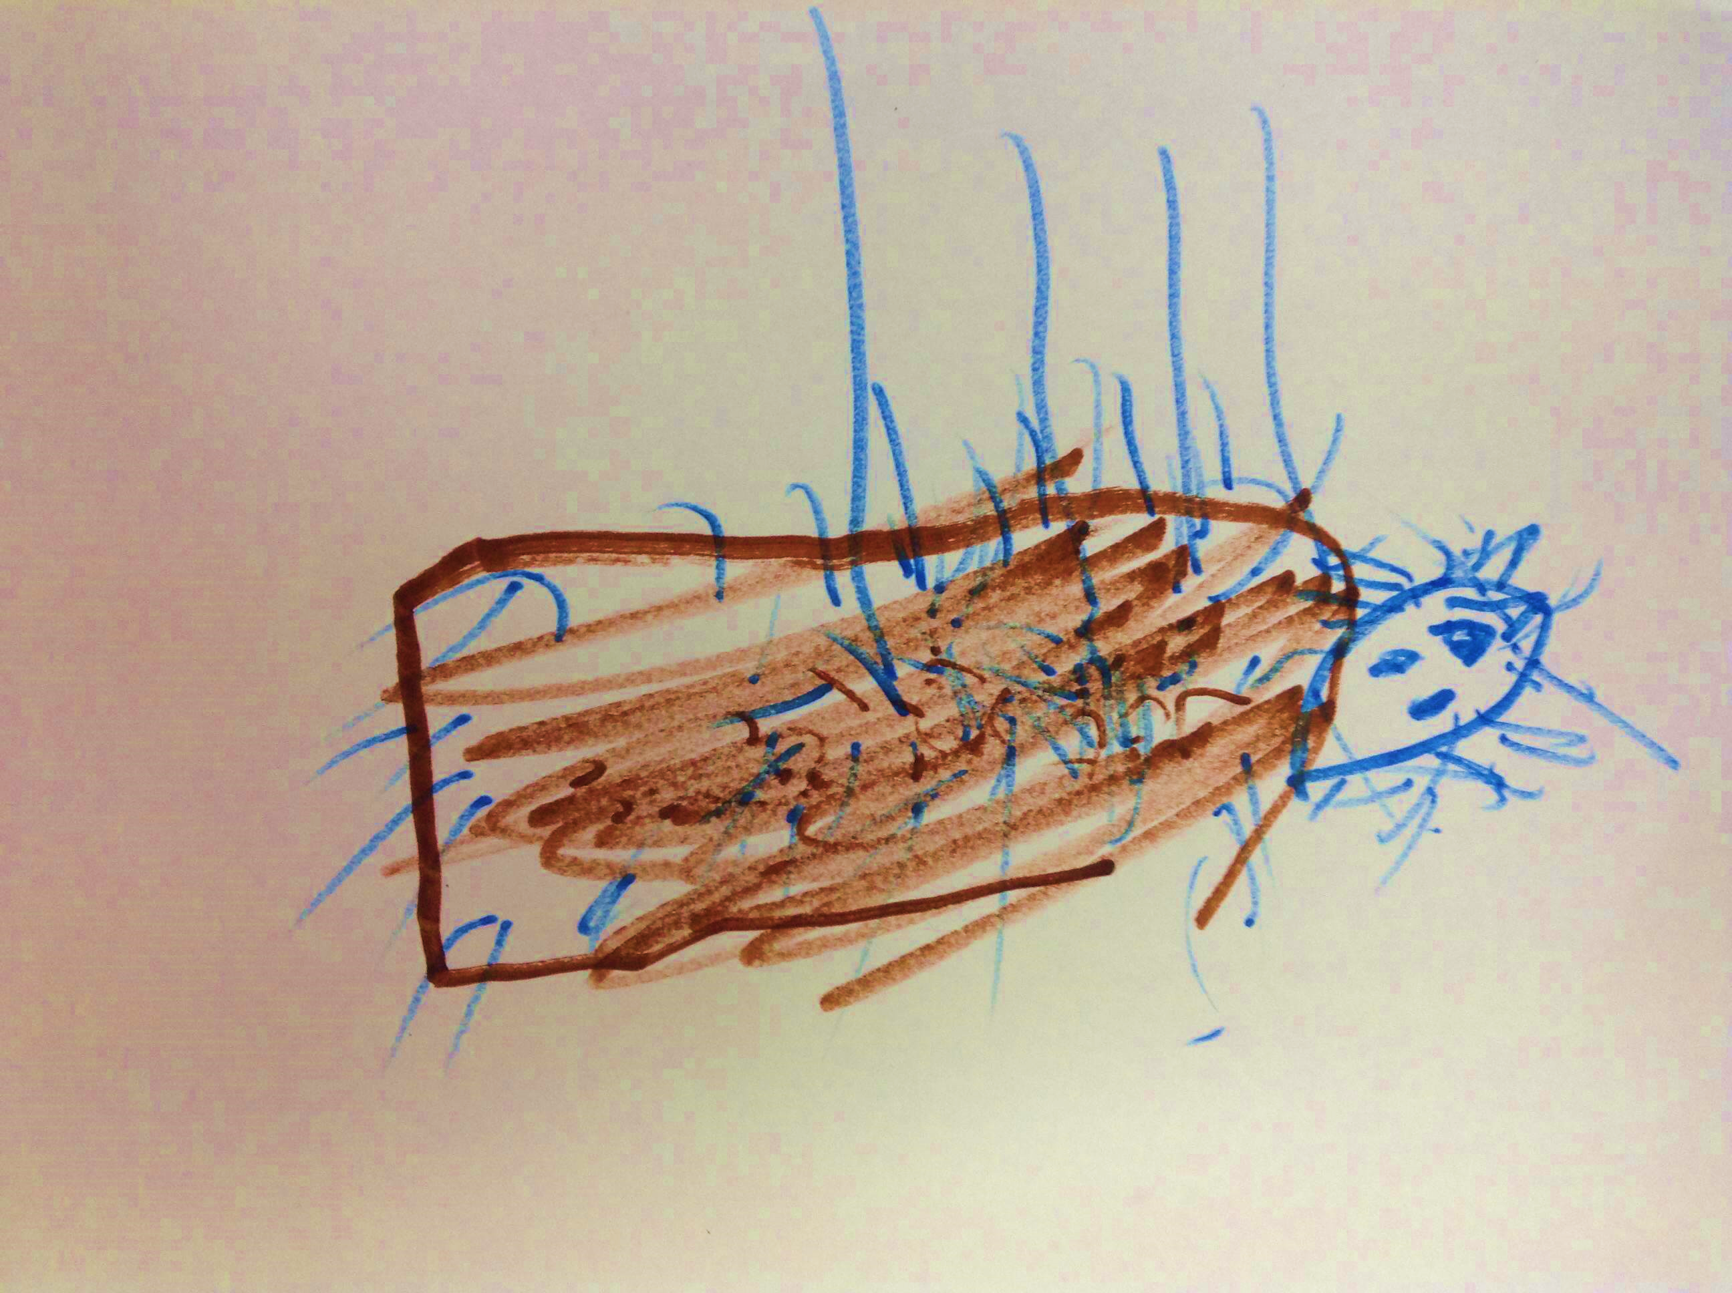 | 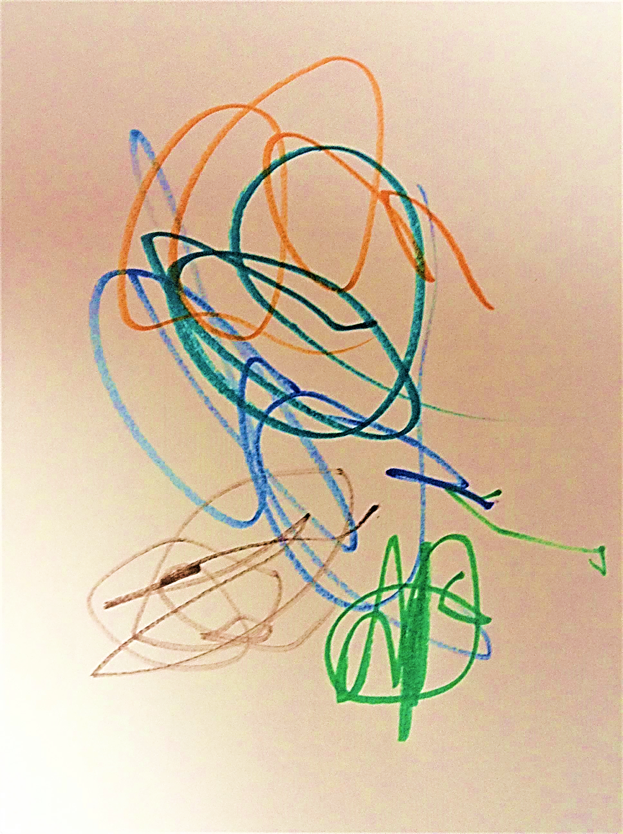 | 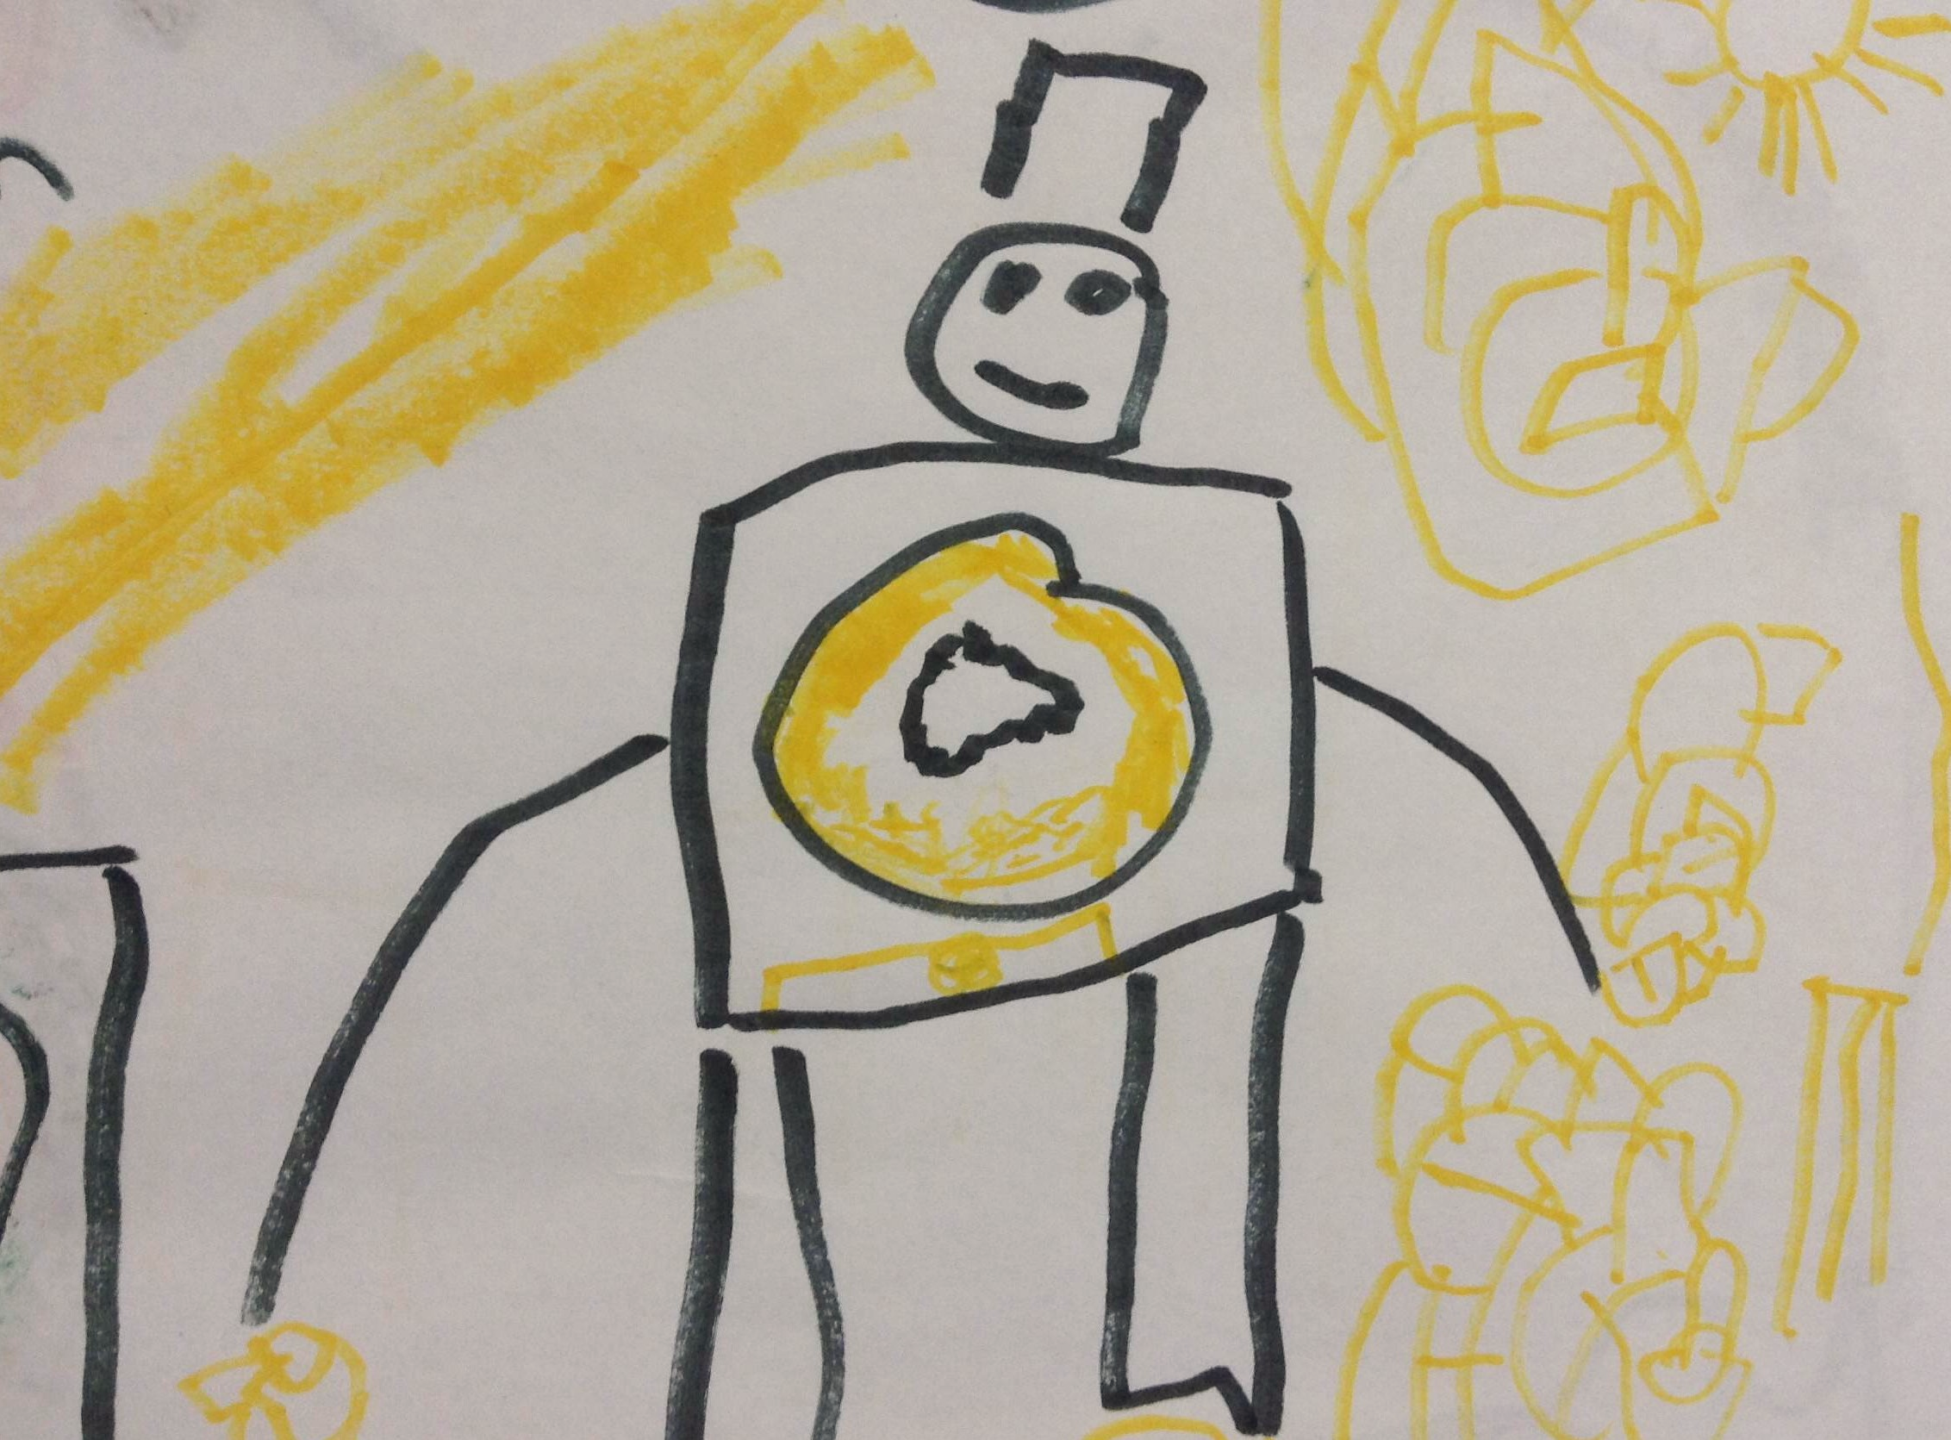 | 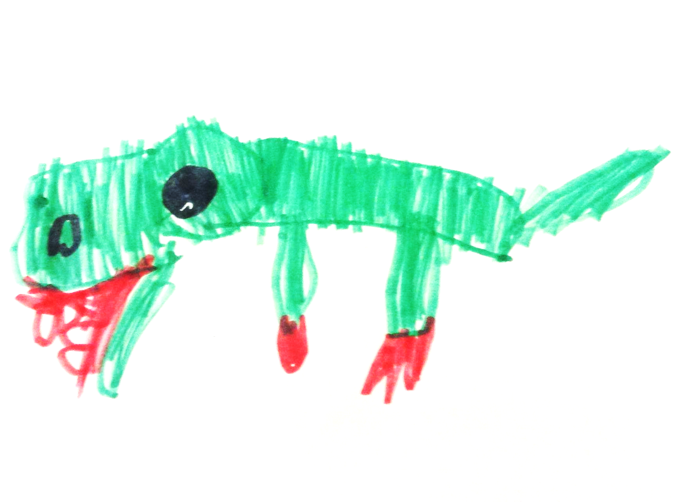 | 